Blockchain HW2
M11215101 謝尚恆

- Create your own token and transfer 100 tokens to TA
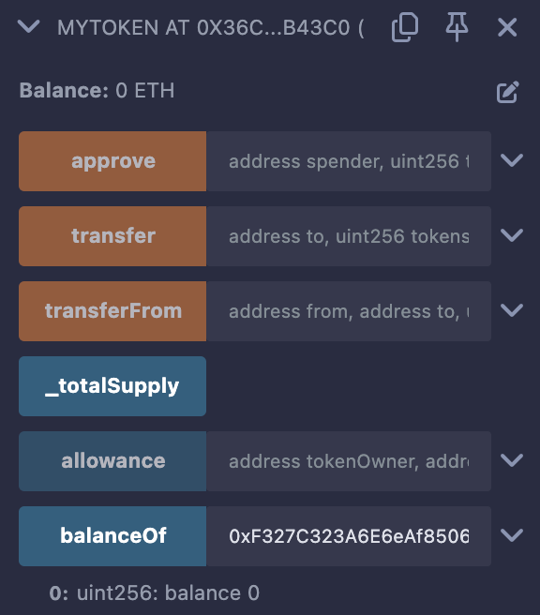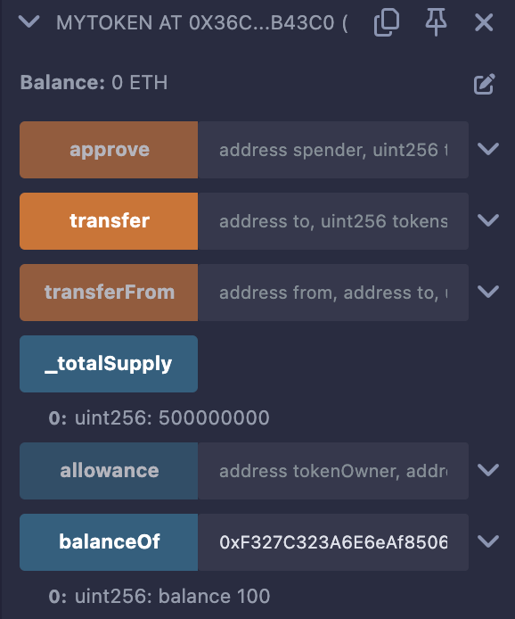
- Write a function similar to the faucet, and you can add some variables for it.
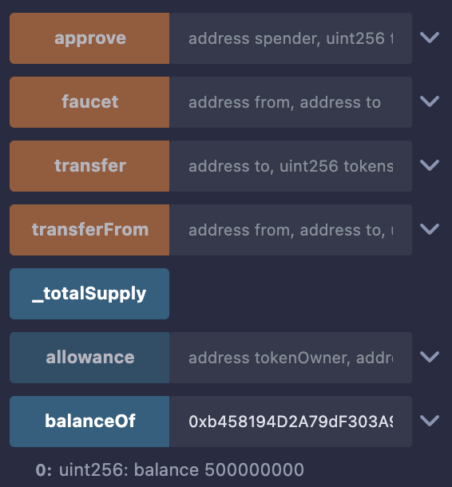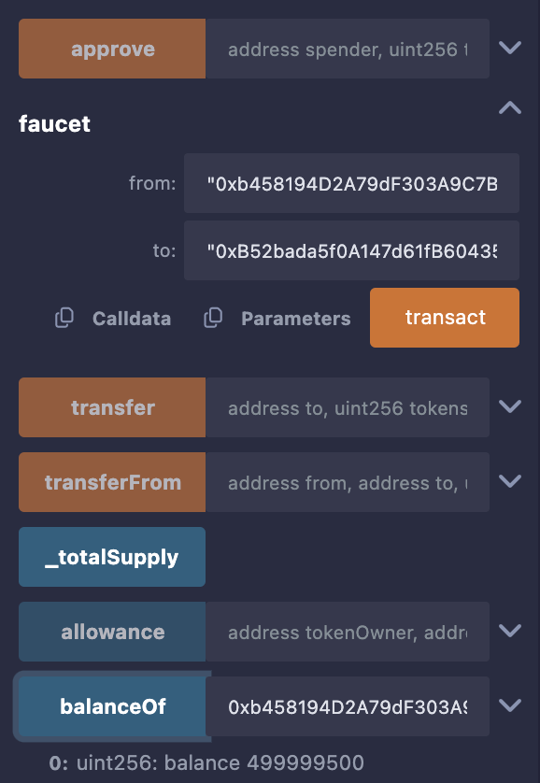
程式解釋：
function faucet(address from, address to) public returns (bool success)
接受兩個地址參數from和to，並且傳回一個布林值表示操作是否成功。

require(from == contractCreator, "Only the contract creator can use the faucet.");
要求from必須是合約創建者

require(block.timestamp > lastFaucet[to] + 30 seconds, "Please wait for 30 seconds before requesting again.");
同一個位址在30秒內只能請求一次代幣。lastFaucet[to]記錄了該位址上次請求的時間戳，block.timestamp > lastFaucet[to] + 30 seconds確保距離上次請求已經過去了至少 30 秒才能讓該位址再次請求代幣。

balances[from] = safeSub(balances[from], 500);
balances[to] = safeAdd(balances[to], 500);

emit Transfer(from, to, 500);
從from轉移500代幣到to

lastFaucet[to] = block.timestamp;
轉移代幣後更新to的時間戳

